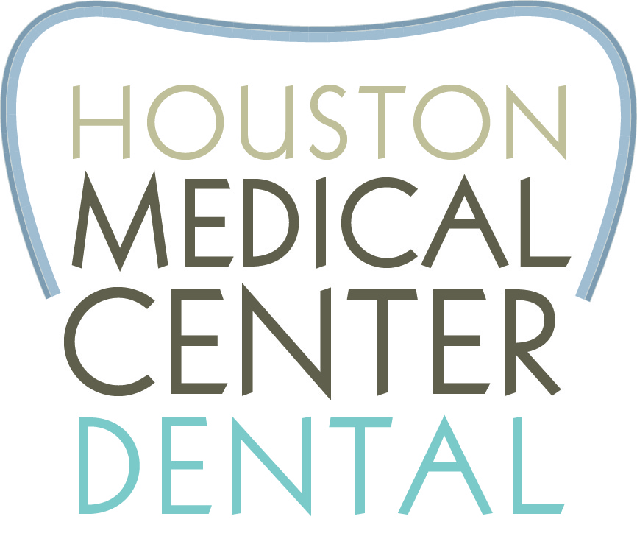

Dear Patient,
This year marks the beginning of many exciting changes. Our vision is to create a warm, welcoming and family-oriented environment that offers quality dental healthcare. We expect, every day, as your team of caring, honest professionals to earn the loyalty and trust of patients, who will in turn appreciate our value and time. We intend to be committed to your overall well-being by focusing on patient education and offering choices of available care, which will impact your health in positive way.

Therefore, the following must be agreed upon:
- No-Shows are not acceptable. Failure to appear at an appointment not only compromises your health, but inconveniences other patients who may have requested an office visit during your scheduled appointment. If you cannot keep an appointment, (except in the case of an emergency) you are expected to call within 24 hours of your appointed time to reschedule, if the 24 hour notice is not given, then the appointment is considered to be a same day cancellation. There is a $100.00 fee for all no-show appointments and same day cancellations; this fee is not covered by insurance.
- We request that you be on time for your visits. If you are more than 15 minutes late, you may be asked to reschedule your appointment.
- If you miss an appointment, we ask that you call to reschedule. It is critical to your health to do so to avoid setbacks in your oral health.
- Payment Policy: Full payment of what you owe is due when services are rendered, unless other arrangements have been made PRIOR to your appointment. We accept cash, personal checks, Visa, MC, AMEX, DISC, CareCredit, and assigned insurance benefits.
- Insurance: Treatment recommendations are based on your healthcare needs not on your insurance or lack thereof. If you have insurance, it is your responsibility to be aware of what your benefits are. Remember insurance companies are not concerned about your health or well-being – we are. As a courtesy we will provide you with an estimate of benefits; however you are fully responsible for any treatment performed. Your benefits are a contract between you and your insurance company. As a reminder, we cannot be responsible for what your insurance will or will not cover. If you have questions regarding your insurance coverage, please contact your insurance company.
- Specialist – at time of scheduling an appointment for treatment, we require 25% of your out-of-pocket expense to reserve and the remaining portion is due at the actual appointment. Please speak with Maria or Rachel if you have any question regarding financial options.
- Emergencies: It is our goal to eliminate all of the potential dental emergencies you may have by providing care for you before it becomes a problem. In the rare instance that you do have an emergency, we will provide you with the next available emergency appointment.

In closing, our goal is to create an exceptional experience every time you visit our office. Please feel free to discuss any issues that arise with our office manager. No problem is too big or too small.

Yours in Health,
Thomas E. Swonke, D.D.S.

By signing below, I acknowledge that I read the Office and Financial Policies form and agree to abide by such policies.
Patient’s Name (print) __________________________________________
Signature ________________________________ Date:______________

